Template for Evidence(s)
UI GreenMetric Questionnaire

University : ...
Country : ...
Web Address : …
SAMPLE
[2] Energy and Climate Change (EC)

[2.15] Impact of Energy and Climate Change programs in supporting the Sustainable Development Goals (SDGs)

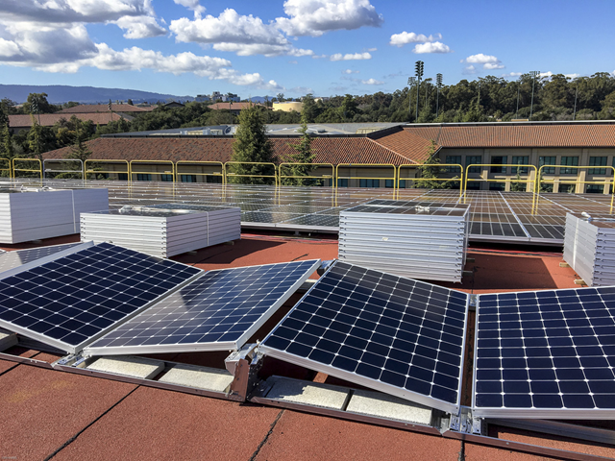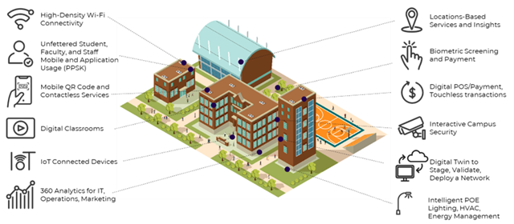
Example

Description:
(Please describe Impact of Energy and Climate Change programs in supporting the Sustainable Development Goals. You can describe more related items if needed.)
The university has undertaken a wide range of energy and climate-related programs that contribute significantly to the achievement of the 17 Sustainable Development Goals (SDGs). These initiatives demonstrate a strong commitment to reducing carbon emissions, enhancing energy efficiency, and fostering climate resilience. Key programs include:
- Installation of solar PV systems on building rooftops and open areas to produce renewable electricity and reduce dependency on fossil fuels.
- Adoption of smart building technologies such as automated lighting systems, motion sensors, and digital energy meters to optimize energy use.
- Campus-wide energy conservation campaigns, including “green office” guidelines, no-AC days, and awareness events to promote responsible energy behavior.
- Implementation of a centralized Building Management System (BMS) to monitor and control HVAC, lighting, and water systems across campus facilities.
- Retrofit programs to replace conventional lighting with LED and energy-efficient equipment in academic and administrative buildings.
- Incorporation of passive design principles in new building construction, including natural ventilation, daylighting, and thermal insulation.
- Carbon footprint assessments conducted annually, covering scope 1 (direct), scope 2 (purchased energy), and scope 3 (mobility, waste).
- Vehicle restriction and green mobility policies, including car-free zones, campus bicycles, electric shuttle buses, and EV charging stations.
- Green building certification initiatives (e.g., local green standards, EDGE, LEED) for new and renovated infrastructure.
- Collaborative climate action plans developed in partnership with local and international organizations to support the university’s sustainability roadmap.
These efforts directly support SDGs 3, 4, 6, 7, 9, 11, 12, 13, and 17, and also contribute indirectly to others, including:
- SDG 3 – Ensuring healthy living environments through improved air quality and indoor climate control
- SDG 4 – Supporting quality education via comfortable and smart learning environments
- SDG 6 – Improving water efficiency in infrastructure operations
- SDG 7 – Increasing the share of affordable, clean energy
- SDG 9 – Innovating with smart infrastructure
- SDG 11 – Building sustainable and low-carbon campuses
- SDG 12 – Promoting responsible energy consumption
- SDG 13 – Addressing climate change through mitigation and adaptation measures
- SDG 17 – Strengthening partnerships for sustainable energy development
Additional evidence link (i.e., for videos, more images, or other files that are not included in this file):

